# cid:image006.jpg@01D50A8F.548E2320

# SCHOOL OF BUSINESS AND LAW - Assignment Feedback Front Sheet SECTION A: *(to be completed by the student)*

|  |  |  |  |
| --- | --- | --- | --- |
| **Please complete Section A in Block Capitals making sure that you include your Student Number, Module Code and Group Number. FAILURE to do so may result in your assignment being delayed. If you are unsure of any of the above please check at the Business School Student Centre Reception.** | | | |
| Student Number | Yuvraj Chauhan | | |
| Programme:(e.g. Business Management) | Master of Business Administration (MBA) | | |
| Module Title: (e.g. Studying for Business) | Marketing in the Digital Age and Corporate Social Responsibility | | |
| Module Code: | MK7040 | Word Count | 3700 |

**I confirm that no part of this assignment, except where clearly quoted and referenced, has been copied from material belonging to any other person e.g. from a book, handout or another student. I am aware that it is a breach of UEL regulations to copy the work of another without clear acknowledgement and that attempting to do so renders me liable to disciplinary proceedings.**

**SECTION B:** *(to be completed by the tutor marking assignment)*

|  |  |  |
| --- | --- | --- |
| **Assessment Criteria:** | **Weightings** | **Mark Achieved** |
| Introduction | 5% | **See Rubric** |
| Segmentation and Targeting | 10% |
| Positioning and Branding | 20% |
| Communication Strategies | 20% |
| Ethical Issues | 30% |
| Conclusion | 5% |
| Structure, Presentation, Referencing | 10% |
| **Total** | **100 marks** |

|  |  |  |  |
| --- | --- | --- | --- |
| **Comments:** | | | |
| **Marker’s Name:** |  | | |
| **Date Received:** |  | **PROVISIONAL  MARK** |  |

**STRATEGIC MARKETING FOR COCA-COLA ZERO SUGAR-FLAVORED COFFEE**

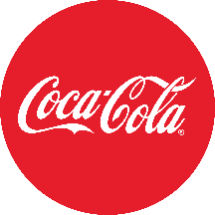

|  |  |
| --- | --- |
| Student Name: | Yuvraj Chauhan |
| Student ID: | 2644211 |
| Module Code | MK7040 |
| Date of Submission | 23/12/2024 |

**Table of Contents**

Part 1: Create an Effective Marketing Strategy in the Digital Age 3

1.1. Introduction 3

1.2. Background of Coca-Cola 3

1.3. Overview of the New Product 4

1.4. Segmentation and Targeting 4

1.4.1 SWOT 4

1.4.2. Market Segmentation 5

1.4.3. Target Market Identification 5

1.4.4. Targeting Strategy 6

1.5. Positioning and Branding 7

1.5.1. Branding & Positioning 7

1.5.2. Brand Image and Personality 10

1.5.3. Brand Awareness and Differentiation 11

1.5.4. Marketing Mix- 4Ps 11

1.5.5. RACE 13

1.5.6. Business model canvas 14

1.6. Chosen Advertisement Medium 14

1.6.1 Proposed Advertisement Plan 14

1.6.2 Media Selection 15

1.6.3. Digital platforms 16

1.6.4. Communication Methods 17

1.6.5 Online Value Proposition 18

Part 2: Marketing Pitch 19

Part 3: CSR and Ethical Issues 20

3.1. Critical Assessment of Current CSR Practices 20

3.1.1. Sustainability Efforts 20

3.1.2. Ethical Manufacturing Practices 20

3.1.3. Product Responsibility 20

3.2. Ethical Issues and Criticism 21

3.3. Recommendations for Improving CSR Practices 22

3.3.1. Environmental Sustainability 22

3.3.2. Community Engagement 22

3.3.3. Ethical Product Lifecycle 22

3.4. Theoretical Perspective 22

4. Conclusion 23

References 24

**List of Figures**

Figure 1: Revenue from operations of Coca-Cola India from financial year 2015 to 2024 5

Figure 2: Targeting Strategies 8

Figure 3: Unique Selling Proposition (USP) 10

Figure 4: Positioning Map 11

Figure 5: Brand Image and Personality 12

Figure 6: Value-Based Strategy 14

Figure 7: Business model canvas 16

Figure 8: Number of users of social media advertising in South Korea 2019-2028 18

Figure 9: Communication Methods 20

Figure 10: Online Value Proposition 21

Figure 11: Marketing Pitch 22

Figure 12: The Triple Bottom Line (TBL) Theory 26

**List of Tables**

Table 1: SWOT 7

Table 2: Market Segmentation 8

Table 3: Branding & Positioning 10

Table 4: Positioning Status 12

Table 5: . Brand Awareness and Differentiation 14

Table 6: RACE 16

Table 7: Digital platforms 20

# Part 1: Create an Effective Marketing Strategy in the Digital Age

## 1.1. Introduction

In today’s competitive market, importing a new product requires a winning marketing strategy. Because of this, companies are better able to understand consumer preferences, target the right audience, and differentiate their products from competitors. Effective planning ensures product placement, brand visibility, and customer engagement. In addition, it helps companies adapt to the local culture, increasing their chances of success in foreign markets. This study will develop Coca-Cola's zero sugar-flavoured coffee marketing strategy, focusing on segmentation, targeting, positioning, branding and digital advertising for health-conscious Seoul consumers in Seoul, South Korea.

## 1.2. Background of Coca-Cola

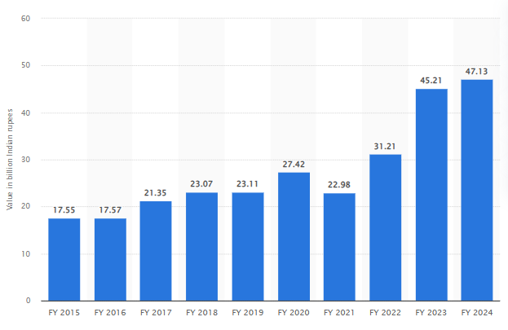

Figure 1: Revenue from operations of Coca-Cola India from financial year 2015 to 2024

(Source: Minhas, 2024)

Since 1886, Coca-Cola’s unique offerings have changed how people think about beverages (Coca-colacompany.com, 2024). In FY 2024, Coca-Cola India's revenue exceeded INR 47 billion, compared to about INR 45 billion in the previous year (Minhas, 2024). This shows a year-on-year increase in revenue in the past (Minhas, 2024). By 2022, sales of Coca-Cola Fiji soft drinks in the Asia Pacific region will increase by more than eight per cent (Rider, 2023). In 2022, Coca-Cola was valued at approximately US$90 billion, making it the world's most valuable soft drink brand (Ridder, 2023).

## 1.3. Overview of the New Product

Coca-Cola Zero Sugar with Flavor Coffee will deliver a tasty buzz from Coca-Cola blended with bold, full-bodied tastes from coffee. So, it has the heavy sweetness of tasty mocha, vanilla and caramel without the guilt of sugar. Its main benefits are energy first, low-calorie second, and ease third, neatly packaged in a fashionable canister. It ultimately will address the rising demand for health products. This product intends to merge two beloved beverages to cleanse and rejuvenate in one drink.

## 1.4. Segmentation and Targeting

### 1.4.1 SWOT

Table 1: SWOT

|  |  |
| --- | --- |
| **Strengths** | **Weaknesses** |
| * Strong brand recognition * Health-conscious appeal * Innovative product * Global reach & distribution * Appeals to multiple demographics | * Limited product variety * Brand perception as a soft drink company * Limited market familiarity * Higher price point * Cultural differences in coffee preferences |
| **Opportunities** | **Threats** |
| * Growing health trend * Expanding coffee market * Product diversification * Influencer partnerships * E-commerce growth | * Intense competition * Shifting consumer preferences * Health criticism * Economic downturns * Regulatory hurdles |

(Source: Self-created)

### 1.4.2. Market Segmentation

Table 2: Market Segmentation

|  |  |  |
| --- | --- | --- |
| Segmentation Criteria | Analysis | Coca-Cola’s Zero sugar-flavored coffee |
| Demographic | Segments based on age, gender, income, etc. | Urban millennials (18-35), health-conscious professionals, high-income coffee drinkers |
| Geographic | Segments based on location | Urban centers, Seoul (South Korea),  countries with growing coffee culture |
| Psychographic | Segments based on lifestyle, interests, values | Health-conscious consumers, active lifestyle enthusiasts, busy professionals |
| Behavioral | Segments based on consumer behavior, such as usage and benefits sought | Consumers seeking low-calorie, energizing beverages, on-the-go drinkers, coffee lovers |
| Occasion-Based | Segments based on special occasions or regular use | Morning pick-me-up, post-workout energy boost, afternoon refreshment |

(Source: Self-created)

### 1.4.3. Target Market Identification

Coca-Cola Zero Sugar Flavored Coffee's target markets are health-conscious coffee drinkers and consumers looking for low-calorie, convenient alternatives to traditional coffee beverages in South Korea. South Korea has a growing demand for innovative coffee beverages, as coffee consumption is increasing, with over 3.17 million bags of coffee consumed in 2022/2023 (Jobst, 2024). Coffee products worth 2.5 trillion South Korean won were sold in retail in 201,8, and liquid coffee and coffee beverage products are dominant categories in the convenience store and coffee shop markets.

Ready-to-drink coffee is also the fastest growing market, and it is targeted at primary customers who are young, urban professionals (age 18–40) (Statista. com, 2024). Targeting such consumers who tend to be busy, prefer convenience, and are leaning toward healthier beverage alternatives, as evidenced by the rise of iced, sugar-free coffee at c-stores (Statista. com, 2024). Coca-Cola Zero Sugar Flavored Coffee makes a lot of sense within this context: 45% of iced coffee sales through 7-Eleven and even more through other convenience store chains, which all appeal to those looking for a quick, refreshing and energising beverage with little or no guilt associated with added sugar (Jobst, 2024).

Also, a semi-active lifestyle where refreshing drinks are often sought after and a focus on health makes the product compatible with specialty coffee, which is refreshing and low in calories

### 1.4.4. Targeting Strategy

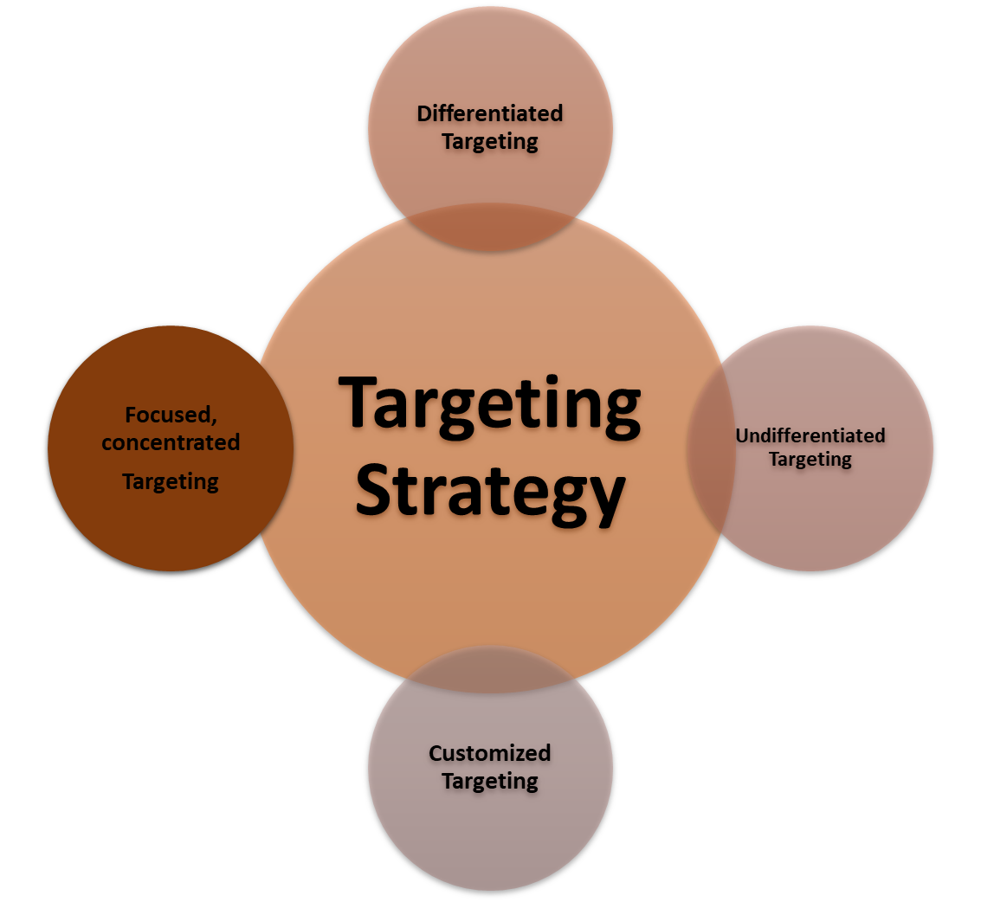

Figure 2: Targeting Strategies

(Source: Self-created)

Coca-Cola Zero Sugar Flavored Coffee is best suited to a differentiated targeting strategy. This strategy focuses on multiple segmenting markets and developing different kinds of products to meet their needs. South Korea's coffee landscape is diverse, with different tastes, health consciousness, and convenience. Coca-Cola's spin on flavoured coffee without sugar could cater to health-conscious coffee drinkers searching for a ready-to-drink (RTD) option (Putithanarak et al., 2022).

Coca-Cola can target millennial professionals who prefer beverages that give them energy but with low-calorie counts and active individuals who need a healthy substitute for a traditional sugary coffee drink. It can also offer coffee lovers flavored possibilities in Gen Z such as mocha, vanilla and caramel simultaneously. Dividing the market into health-conscious consumers on one side and flavour-oriented coffee drinkers on the other helps Coca-Cola create compelling messages and marketing strategies addressing both parties of this micro-market.

This strategy effectively capitalises on the growing coffee culture in South Korea and allows for an approach that meets the specific needs of different consumer groups.

## 1.5. Positioning and Branding

### 1.5.1. Branding & Positioning

Table : Branding & Positioning

|  |  |  |  |  |
| --- | --- | --- | --- | --- |
| Aspect | Coca-Cola Zero Sugar Flavored Coffee | Starbucks | Nescafé | Monster Energy Java Coffee |
| **Positioning** | Low-calorie, flavored coffee with Coca-Cola taste. | Premium, high-quality coffee experience. | Affordable, everyday coffee for all. | Energy-packed coffee for active individuals. |
| **Target Market** | Health-conscious coffee lovers. | Coffee enthusiasts and professionals. | Everyday coffee drinkers. | Young adults and athletes. |
| **Brand Image** | Refreshing and modern. | Premium and sophisticated. | Reliable and accessible. | Bold and energetic. |
| **Product Range** | Flavored, zero-sugar coffee beverages. | Hot/iced drinks and premium coffee beans. | Instant, ground, and RTD coffee. | Coffee energy drinks. |
| **Marketing Approach** | Digital, health-focused. | Experiential, in-store and digital. | Traditional and digital media. | Social media and influencer-driven. |
| **Differentiation** | Unique blend of Coca-Cola and coffee. | Focus on premium quality. | Convenience and variety. | Combines energy drink benefits with coffee taste. |

(Source: Self-created)

#### 1.5.1.1 Unique Selling Proposition (USP)

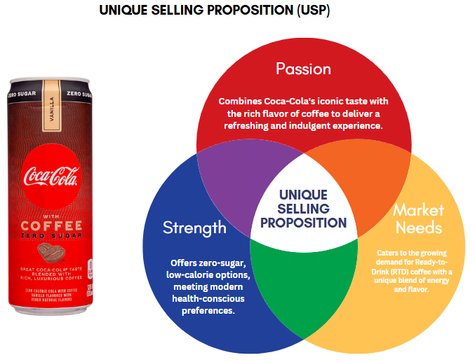

Figure : Unique Selling Proposition (USP)

(Source: Self-created)

* **Passion**: It combines the exotic taste of Coca-Cola with the sweet taste of coffee for a refreshing and enjoyable experience.
* **Strength**: Provides sugar-free, low-calorie products that meet today’s essential healthcare needs.
* **Market need:** The growing demand for ready-to-drink (RTD) coffee with a unique blend of strength and flavour requires a unique blend (Yoon et al., 2023).

#### 1.5.1.2 Positioning Map

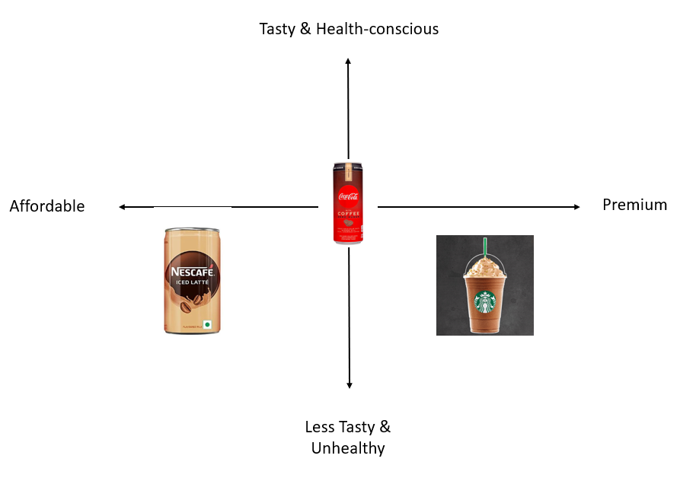

Figure : Positioning Map

(Source: Self-created)

Table : Positioning Status

|  |  |  |  |
| --- | --- | --- | --- |
| **Positioning Map** | **Coca-Cola Zero Sugar Flavored Coffee** | **Starbucks Ready-to-Drink Coffee** | **Nescafé Ready-to-Drink Coffee** |
| **Price** | Affordable, mid-range | Premium, higher price  (Hurdawaty et al., 2023) | Low-cost, budget-friendly |
| **Taste** | Sweet and bold flavors (mocha, vanilla, caramel) | Rich coffee flavors with various variations | Mild coffee taste, less variety |
| **Target Audience** | Health-conscious, on-the-go consumers | Coffee connoisseurs, luxury seekers | Budget-conscious, everyday drinkers |
| **Product Offering** | Ready-to-drink coffee with zero sugar | Premium iced and hot coffee options | Instant coffee, RTD coffee drinks |
| **Brand Image** | Refreshing, energizing, health-focused | Premium, high-quality coffee brand | Reliable, budget-friendly choice |

(Source: Self-created)

### 1.5.2. Brand Image and Personality

Coca-Cola Zero Sugar Flavored Coffee leans toward a contemporary, lively, health-oriented brand image targeting active urban citizens. Combining Coca-Cola's classic refreshment background with premium coffee culture, the brand has an energetic, innovative, and inclusive personality. It caters to those searching for indulgence without guilt, gratification and functionality.

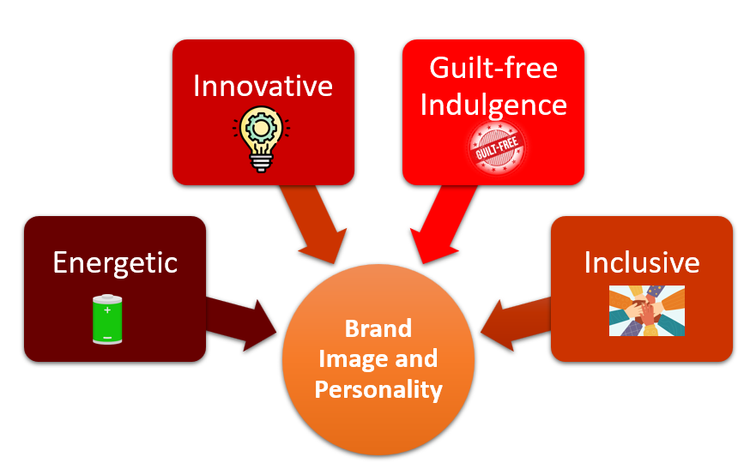

Figure : Brand Image and Personality

(Source: Self-created)

The brand personality projects an image that is quite ambitious yet prominent and walkable and beautifully depicts its dual nourishment of refreshment and stimulation. It employs sharp, modern packaging and high-energy digital marketing in its visual identity to target younger consumers. With Coca-Cola Zero Sugar Flavored Coffee, we're encapsulating an active, on-the-go lifestyle while encouraging mindful consumption. With Coca-Cola being one of the most recognised brands worldwide, the concept of flavoured water resonated with consumers who like healthier drinks that offer more flavour profiles – a win between the brand and the end consumer.

### 1.5.3. Brand Awareness and Differentiation

Table : . Brand Awareness and Differentiation

|  |  |  |
| --- | --- | --- |
| Branding Strategy Component | Details | Specific Examples for Coca-Cola Zero Sugar Flavored Coffee |
| Brand Identity | Represents a fusion of Coca-Cola's refreshment and coffee's sophistication. | Combines Coca-Cola’s legacy with the innovative flavor profile of coffee in a guilt-free, sugarless format. |
| Visual Elements | Distinctive logo, color palette, and packaging design that reflect energy and elegance. | Sleek black and red packaging with coffee motifs, emphasizing a premium yet approachable feel. |
| Brand Ambassadors | Influential personalities who align with the brand's energetic and modern image. | Collaboration with fitness influencers or urban lifestyle bloggers to target health-conscious consumers. |
| Consistency in Messaging | Uniform communication across all platforms, emphasizing innovation, energy, and health-consciousness. | Tagline like "Sip the Future of Refreshment" used in digital ads, social media, and convenience stores. |

(Source: Self-created)

### 1.5.4. Marketing Mix- 4Ps

**Product**

Coca-Cola Zero Sugar Flavored Coffee combines Coke's classic fizz and mocha, vanilla and caramel-flavored coffee notes. The sugar-free formula appeals to health-conscious buyers. It comes in a can, which is ideal for hectic lifestyles. The product stands out with a unique blend of two popular drinks, a refreshing and energising experience, and a response to a growing demand for energised, better-for-ready-to-drink beverages.

**Price**

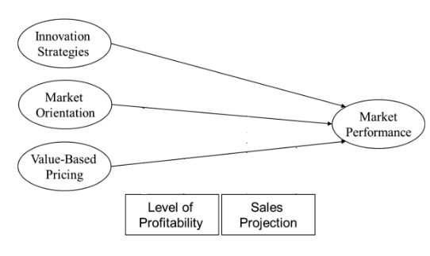

Figure : Value-Based Strategy

(Source: De Toni et al., 2022)

Coca-Cola’s sugar-free coffee will use a ***Value-Based Strategy***, set in an affordable but premium price range to appeal to South Korean consumers who are price-conscious but quality-conscious (De Toni et al., 2022). Strong demand for high-consumption coffee and ready-to-drink (RTD) beverages for this competitive pricing and a market tendency toward convenience and creativity that guarantees more can be achieved if money has been valuable to and helped the brand maintain a high profile in the hot coffee space.

**Place**

Coca-Cola Zero Sugar Flavored Coffee will be available throughout South Korea at the nation’s convenience stores (GS25, 7-Eleven, etc.), supermarkets, and online channels. Beverages sales are split across more channels than any other product type, with coffee products being the single largest class of goods sold through convenience stores, making up 40% of the volume (Jobst, 2024). The convenience and ubiquity of the snacks make it ideal for the fast life of South Koreans. Also, having e-commerce channels will allow tech-savvy consumers to access the product while covering the wide demographic spread and supporting the fast-paced South Korean retail infrastructure.

**Promotion**

Coca-Cola Zero Sugar Flavored Coffee will be promoted using ***digital marketing on social media channels*** such as Instagram and KakaoTalk, both popular in South Korea (Peter and Dalla Vecchia, 2021). Influencer campaigns and Instagram/TikTok ads will be leveraged to reach tech-savvy consumers (Khrais and Gabbori, 2023). Moreover, regular buyers will be lured due to in-store promotions at convenience stores and through loyalty programs. The tactics align with the high level of digital penetration by the South Korean population and a preference for visible advertising strategies that are potentially interactive and localised as per the viewer population aged 18-40.

### 1.5.5. RACE

Table : RACE

|  |  |  |
| --- | --- | --- |
| RACE Framework | Goal | Methods |
| Reach | Increase awareness of Coca-Cola Zero Sugar Flavored Coffee | Digital ads on social media platforms (Instagram, KakaoTalk), influencer partnerships, in-store promotions, and outdoor billboards. |
| Act | Engage consumers and encourage trials | Interactive social media content, convenience store product sampling, special offers, and limited-time discounts (Hartanto et al., 2022). |
| Convert | Convert interest into sales | Online purchase options, loyalty programs, subscription services for regular deliveries, and collaborations with e-commerce platforms are also available (Al-Azzam and Al-Mizeed, 2021). |
| Engage | Foster customer loyalty and repeat purchases | Email newsletters, customer feedback surveys, exclusive promotions for loyal customers, and continued engagement through social media interactions. |

(Source: Self-created)

### 1.5.6. Business model canvas

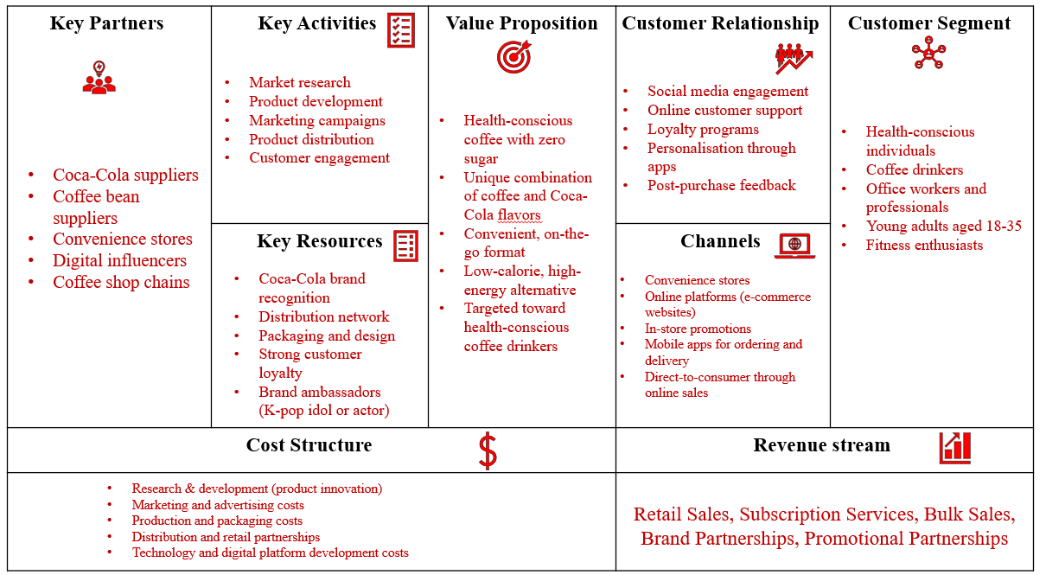

Figure : Business model canvas

(Source: Self-created)

## 1.6. Chosen Advertisement Medium

### 1.6.1 Proposed Advertisement Plan

**Objective:**Coca-Cola Zero Sugar Flavored Coffee will raise awareness and drive sales by introducing Coca-Cola's unique refreshment beverage, which combines flavoured and sugar-free coffee.

**Target Audience:**

In South Korea, health-conscious individuals aged 18-40, coffee enthusiasts, and young professionals are looking for low-calorie and convenient drinks.

**Key Message:**"Enjoy the bold energy of coffee with the refreshing taste of Coca-Cola—now with zero sugar!"

**Advertisement Mediums:**

1. **Digital Platforms (Social Media and Influencers):**

* Leverage popular platforms like Instagram, Facebook and TikTok, where influencers express passion and comfort with products.
* Example: Fitness influencers promote it as the best post-workout booster.

1. **In-store Promotions and Sampling:**

Sampling in convenience stores, cafes and supermarkets to promote product trials. Offer timely discounts just to incentivise purchases.

1. **Billboards and Outdoor Advertising:**

Strategic placements near coffee shops and busy areas like subways showcase the product's dual appeal (refreshing Coca-Cola and coffee).

1. **TV & Online Ads:**

Short, energetic ads highlight the product’s unique combination and health benefits.

### 1.6.2 Media Selection

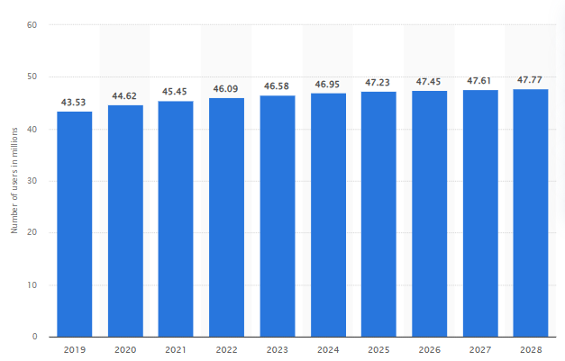

Figure : Number of users of social media advertising in South Korea 2019-2028

(Source: Jobst, 2024)

South Korea will lead the world in internet connectivity with 92.6% mobile internet penetration by 2024 (Statista.com, 2024). South Korea has the fastest internet speed (Jobst, 2024). Instagram, TikTok, and YouTube are becoming increasingly popular as social media becomes more integrated into everyday life. Instagram has surpassed Facebook's active users, making it ideal for networking with South Korea’s tech-savvy youth. Social media advertiser users reached 46.6 million by 2023 and are expected to grow 2.6% annually through 2028 (Jobst, 2024). Smartphone penetration led to a 549% revenue growth in mobile advertising in 2013 between 2021 (Jobst, 2024). A central digital advertising campaign will cost South Korea $8 billion. Advertising Coca-Cola Zero Sugar Flavored Coffee's marketing campaign, which is currently booming, is an excellent opportunity (Jobst, 2024).

### 1.6.3. Digital platforms

Table : Digital platforms

|  |  |  |  |
| --- | --- | --- | --- |
| Digital Platform | Target Audience | Platform Characteristics | Reason for Selection |
| Instagram | Young, health-conscious, tech-savvy consumers | Visual content, influencer engagement, product discovery | Popular among South Koreans, highly visual and interactive platform for product promotion |
| TikTok | Gen Z and Millennials | Short-form video content, viral challenges, trends-driven | High engagement, ideal for reaching younger demographics with creative, engaging content |
| YouTube | All age groups, especially 18-34 | Long-form videos, tutorials, product reviews, ads | Popular platform for video content, allows detailed product demonstrations and engagement |
| Naver Blog | Broad, including older demographics | Text-based content, reviews, influencer collaborations | Popular among South Korean users for product recommendations and detailed content |
| KakaoTalk | All demographics, heavily used for messaging | Messaging, group chats, influencer promotions, integration with e-commerce | Popular messenger app in South Korea, good for direct communication and promotions |

(Source: Self-created)

### 1.6.4. Communication Methods

Coca-Cola zero sugar flavoured coffee in South Korea will use digital communication, influencer marketing and interactive promotions. The methods include:

Figure : Communication Methods

(Source: Self-created)

Coca-Cola Zero Sugar Flavored Coffee will use a ***Linear Communication Strategy*** in South Korea. This model uses a one-way communication system (Meenambal and Meenakshi, 2022). The company uses social media advertising and influencer terms to reach the audience. It is essential to emphasise the flavour of the coffee and the sugar-free nature of the product. Likes, comments and shares are used to measure feedback. The linear model facilitates message delivery by immediately incorporating persuasive and straightforward information by health-conscious consumers, especially for new products

### 1.6.5 Online Value Proposition

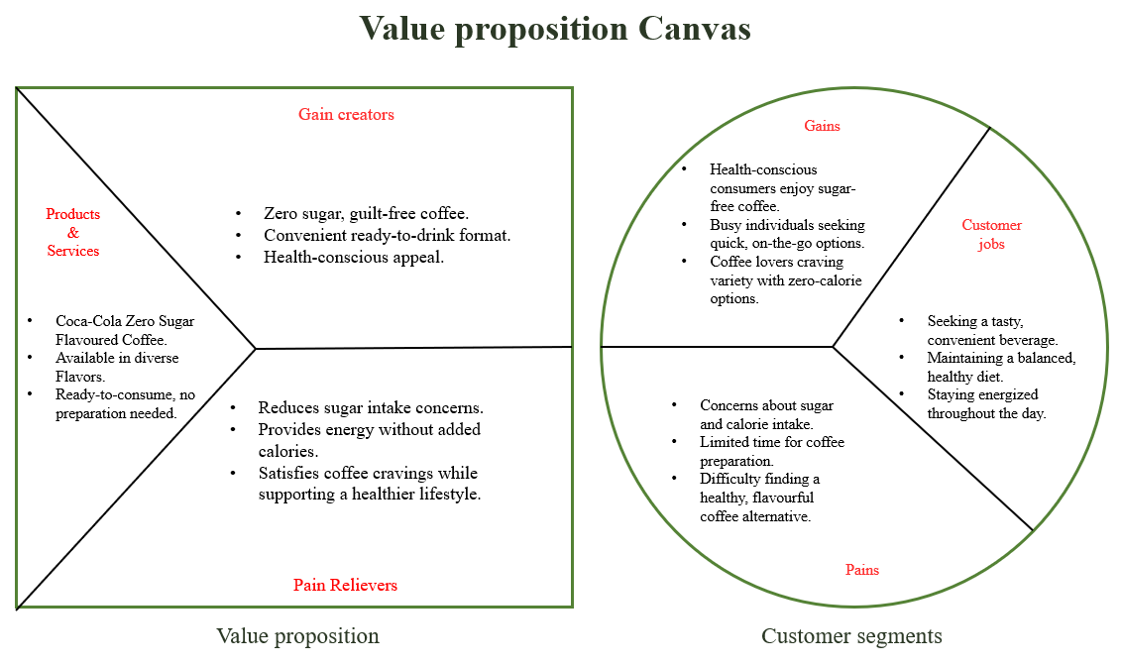

Figure : Online Value Proposition

(Source: Self-created)

# Part 2: Marketing Pitch

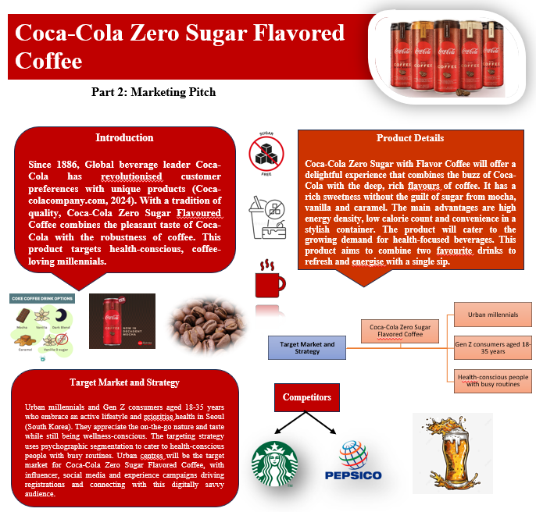

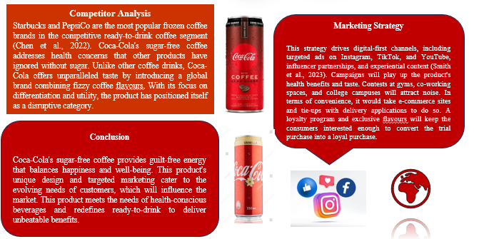

Figure : Marketing Pitch

# Part 3: CSR and Ethical Issues

## 3.1. Critical Assessment of Current CSR Practices

### 3.1.1. Sustainability Efforts

Coca-Cola’s sustainability programs emphasise how a comprehensive strategy, including social, environmental and fiscal responsibility, will help build a better future. By 2025, the company wants all packaging to be recyclable (Coca-cola.com, 2024). By 2030, it intends to include at least 50% recycled content. Great strides have been made in water management. Since 2010, water consumption has decreased by 32.4%, and its water injection rate is 159.9% (Coca-cola.com, 2024). Under the Unnati project, Coca-Cola’s fruit circular economy program advocates densely populated fruit farms, thus improving agricultural production (Coca-cola.com, 2024). The Coca-Cola project reflects a desire to change business processes for the benefit of people, communities and the environment, thus promoting a sustainable future and ensuring positive change

### 3.1.2. Ethical Manufacturing Practices

Quality, food safety and regulatory compliance throughout the supply chain are indispensable to Coca-Cola's commitment to ethical manufacturing best practices (Coca-colacompany.com, 2024). The company implements extensive supplier requirements, complies with regulations, and fosters safe behaviour preoccupation with environmental preservation, emphasising water, climate, and packaging (Coca-colacompany.com, 2024). Coca-Cola has health and safety programs that guarantee a safe working environment and continuously raise global health and safety standards.

### 3.1.3. Product Responsibility

Coca-Cola’s commitment to product responsibility includes providing high-quality, safe beverages that meet consumer expectations (Coca-colacompany.com, 2024). The company guarantees that every product follows international food safety regulations. Coca-Cola supports responsible consumption, aiming to 100% recycling by 2025, especially concerning sugar and health care evidence (Coca-colacompany.com, 2024).

## 3.2. Ethical Issues and Criticism

**Plastic Pollution and Coca-Cola’s Role:**

* Coca-Cola has been crowned the world’s biggest plastic polluter for many years in the annual report of the ***Break Free From Plastic*** campaign (Laville, 2022).
* Even though Coca-Cola tells its customers it maintains eco-friendly practices, the reality is as stark as ever: It adds millions of plastic bottles to landfills and oceans. Its packaging is largely single-use plastic, producing 120 billion plastic bottles annually (Laville, 2022).
* Coca-Cola has committed to collecting and recycling one bottle for every bottle sold worldwide and has pledged to make all its packaging recyclable by 2030 to reduce plastic waste (Laville, 2022). Critics say the target needs to be increased, and the company should focus more on recycling consumer plastics (Laville, 2022).

**Recycled Materials and Greenwashing:**

* Coca-Cola's promo efforts have included images of bottles made with 25% marine plastic, which the company has called greenwashing (Leggett and Edser, 2023). These efforts hide the truth that the company is a top plastic pollution culprit. This form of recyclable plastic is not even recyclable everywhere, and it does little to contribute to solving the overall global plastic crisis.

**Health Concerns and Artificial Sweeteners:**

* Coca-Cola’s many sugar-free ingredients include aspartame. Despite FDA and other health approvals, aspartame was classified as a ***"possible carcinogen"*** by the International Agency for Research on Cancer (IARC) by 2023. Concerns about this classification remain (Harris and Mundy, 2024).
* Health groups, including the Interfaith Center for Corporate Responsibility (ICCR), have sent resolutions to Coca-Cola for implementation (Harris and Mundy, 2024). These measures suggest that chronic health issues can pose systemic financial risk to organisations.
* Coca-Cola and other soda companies claim that aspartame does not cause cancer. Critics say the lack of trust calls for more transparent and vigilant choices.

**Sugar Taxes and Public Health:**

* Due to rising international alarm over how sugary drinks contribute to obesity and diabetes, many countries—including the UK, Mexico, and some US states have imposed sugar taxes. Such taxes hit Coca-Cola's profits where it hurts.
* As reported in The Guardian, sugar taxes, with which ***ShareAction,*** an organisation advocating for improved corporate health and environmental performance, has become familiar, are more prevalent than carbon taxes (Laville, 2022). Coca-Cola has responded by introducing sugar-free products and brands, but some doctors say these drinks are still unhealthy for consumer health.
* Coca-Cola and PepsiCo have jointly committed $10 million to fight sugar taxes and restrictions in many countries by 2020, highlighting the conflict between public health and business interests (Laville, 2022).

## 3.3. Recommendations for Improving CSR Practices

### 3.3.1. Environmental Sustainability

Coca-Cola must reduce its plastic footprint and focus on source reduction rather than recycling. Sustainable methods of manufacture, such as using minimal packaging or switching to alternative biodegradable materials, will prevent reliance on plastics in the first instance. Enhancing the recyclability of materials through investment in *closed-loop recycling systems* and collaboration with other companies to build sustainable packaging infrastructure (Zhang et al., 2021). Increasing use of renewable energy in manufacturing plants can reduce carbon emissions by a great deal.

### 3.3.2. Community Engagement

Coca-Cola needs to invest further in local environmental and social programs to create better local connections by collaborating with local NGOs and governments to finance projects focused on water availability, education, and health care in underprivileged areas of villages (Lipták and Prónay, 2020). To further improve transparency, Coca-Cola could produce year-on local community impact reports detailing how they identify and respond to local needs by building lasting relationships with local communities (Silva, 2024).

### 3.3.3. Ethical Product Lifecycle

As Coca-Cola has done, replacing plastic with ecological alternatives so that all packaging material is 100% recyclable or compostable will improve products' life cycles (Nordahl and Scown, 2024). The company should also pledge to discontinue harmful ingredients like artificial sweeteners and prioritise more nutritionally beneficial options in product development. A complete product take-back program with recycling and consumer incentives to return bottles for reuse will extend sustainability across the product lifecycle.

## 3.4. Theoretical Perspective

**Triple Bottom Line (TBL) Theory**

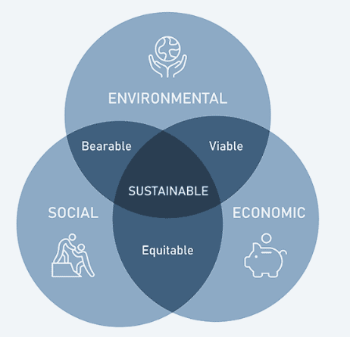

Figure : The Triple Bottom Line (TBL) Theory

(Source: Nogueira et al., 2023)

The Triple Bottom Line (TBL) principle balances three key pillars—people, planet, and profit (Tseng et al., 2020). According to this perspective, firms should consider their success from a social and environmental perspective in addition to economic. Implementing the Coca-Cola TBL program can offset the increased ecological impact by reducing carbon emissions and plastic waste, thereby increasing the quality of life through community support projects and enhancing the benefits of sound business practices. Integration of TBL into CSR initiatives Risks associated with Coca-Cola’s social and environmental aspects information will help reduce but provide ongoing benefits for the company and the public (Nogueira et al., 2023).

# 4. Conclusion

Coca-Cola Zero Sugar Flavored Coffee combines the famous flavour of Coca-Cola with South Korea’s renowned coffee culture, meeting the growing demand for healthy, low-calorie beverages—the Approach segmentation, targeting, and positioning can help Coca-Cola reach urbanites and health-conscious employees. Digital media, influencer marketing, and sampling programs increase brand recognition and product trials. Health issues related to sustainability and confectionery must be addressed to improve brand reputation. Coca-Cola can maintain its brand reputation and customer loyalty by enhancing CSR initiatives and focusing on sustainable and ethical environmental practices.

# References

Al-Azzam, A. F. and Al-Mizeed, K. (2021) The effect of digital marketing on purchasing decisions: A case study in Jordan. *The Journal of Asian Finance, Economics and Business*, *8*(5), 455-463.

Chen, L., Wu, W., Zhang, N., Bak, K. H., Zhang, Y. and Fu, Y. (2022) Sugar reduction in beverages: Current trends and new perspectives from sensory and health viewpoints. *Food Research International*, *162*, 112076.

Coca-cola.com, (2024). Our Planet Matters. [Online] Available at: https://www.coca-cola.com/in/en/sustainability#:~:text=Focusing%20on%20a%20world%20without,in%20our%20packaging%20by%202030. [Accessed on: 11.12.2024]

Coca-colacompany.com, (2024) About Coca-Cola. [Online] Available at: https://www.coca-colacompany.com/about-us [Accessed on: 20.11.2024]

Coca-colacompany.com, (2024). PEOPLE SAFETY & PRODUCT QUALITY. [Online] Available at: https://www.coca-colacompany.com/sustainability/product-quality-safety [Accessed on: 11.12.2024]

De Toni, D., Reche, R. A. and Milan, G. S. (2022) Effects of market orientation, innovation strategies and value-based pricing on market performance. *International Journal of Productivity and Performance Management*, *71*(8), 3556-3580. https://doi.org/10.1108/IJPPM-08-2020-0414

Harris. L. and Mundy, S. (2024). Coca-Cola and Pepsi face investors’ bubbling health concerns. [Online] Available at: https://www.ft.com/content/f3e6dbef-6a27-4fef-836c-710a298eba47 [Accessed on: 11.12.2024]

Hartanto, Y., Firmansyah, M. A. and Adhrianti, L. (2022, April) Implementation digital marketing pesona 88 curup in to build image for the decision of visit tourist attraction. In *4th social and humanities research symposium (SoRes 2021)* (pp. 589-594). Atlantis Press.

Hurdawaty, R., Wibowo, F. S. and Sulistiyowaty, R. (2023) Studying the Consumption Behaviour of Generations Y and Z towards Ready-To-Drink Coffee. *International Journal of Travel, Hospitality and Events*, *2*(1), 10-26.

Jobst, N. (2024) Sales share of iced coffee in leading convenience store brands in South Korea between 2022 and 2023. [Online] Available at: https://www.statista.com/statistics/1387199/south-korea-iced-coffee-sales-share-in-convenience-stores/ [Accessed on: 11.12.2024]

Jobst, N. (2024) Social media usage in South Korea - Statistics & Facts. [Online] Available at: https://www.statista.com/topics/5274/social-media-usage-in-south-korea/#topicOverview [Accessed on: 11.12.2024]

Jobst, N. (2024) Total coffee consumption in South Korea from 2019 to 2022/2023. [Online] Available at: https://www.statista.com/statistics/314992/south-korea-total-coffee-consumption/ [Accessed on: 11.12.2024]

Khrais, L. T. and Gabbori, D. (2023) The effects of social media digital channels on marketing and expanding the industry of e-commerce within digital world. *Periodicals of Engineering and Natural Sciences (PEN)*, *11*(5), 64-75.

Laville, S. (2022) Coca-Cola among brands greenwashing over packaging, report says. [Online] Available at: https://www.theguardian.com/environment/2022/jun/30/coca-cola-among-brands-greenwashing-over-packaging-report-says [Accessed on: 11.12.2024]

Leggett, T. and Edser, N. (2023) Coca-Cola and Nestle accused of misleading eco claims [Online] Available at: https://www.bbc.com/news/business-67343893 [Accessed on: 11.12.2024]

Lipták, L. and Prónay, S. (2020) Using controversial values in CSR communication–analyzing the Coca-Cola# loveislove campaign. *Proceedings of European Marketing Academic*.

Meenambal, D. S. and Meenakshi, S. (2022) The effectiveness of communication strategies to develop the communicative competency of ESL learners. *Theory and Practice in Language Studies*, *12*(10), 1961-1968.

Minhas, A. (2024) Revenue from operations of Coca-Cola India from financial year 2015 to 2024. [Online] Available at: https://www.statista.com/statistics/1287217/coca-cola-india-revenue-from-operations/ [Accessed on: 11.12.2024]

Nogueira, E., Gomes, S. and Lopes, J. M. (2023) Triple bottom line, sustainability, and economic development: What binds them together? A bibliometric approach. *Sustainability*, *15*(8), 6706.

Nordahl, S. L and Scown, C. D. (2024) Recommendations for life-cycle assessment of recyclable plastics in a circular economy. *Chemical Science*, *15*(25), 9397-9407.

Peter, M. K. and Dalla Vecchia, M. (2021) The digital marketing toolkit: a literature review for the identification of digital marketing channels and platforms. *New trends in business information systems and technology: Digital innovation and digital business transformation*, 251-265. https://doi.org/10.1007/978-3-030-48332-6_17

Putithanarak, N., Klongthong, W., Thavorn, J. and Ngamkroeckjoti, C. (2022) Predicting consumers' repurchase intention of ready-to-drink coffee: a supply chain from Thai producers to retailers. *Journal of Distribution Science*, *20*(5), 105-117.

Ridder, M. (2023) Coca Cola Company: global beverage sales volume growth 2022, by type. [Online] Available at: https://www.statista.com/statistics/670402/coca-cola-company-beverage-volume-growth-worldwide-by-type/[Accessed on: 11.12.2024]

Silva, J. A. (2024). Corporate Social Responsibility (CSR) and Sustainability in Water Supply: A Systematic Review. *Sustainability*, *16*(8), 3183.

Smith, M. J., Buckton, C., Patterson, C. and Hilton, S. (2023) User-generated content and influencer marketing involving e-cigarettes on social media: a scoping review and content analysis of YouTube and Instagram. *BMC Public Health*, *23*(1), 530.

Statista.com, (2024) Digital advertising in South Korea - statistics & facts. [Online] Available at: https://www.statista.com/topics/10268/digital-advertising-in-south-korea/#topicOverview [Accessed on: 11.12.2024]Jobst, N. (2024) Number of users of social media advertising in South Korea 2019-2028. [Online] Available at: https://www.statista.com/statistics/247943/number-of-social-network-users-in-south-korea/ [Accessed on: 11.12.2024]

Statista.com, (2024) Ready-to-Drink (RTD) Coffee - South Korea. [Online] Available at: https://www.statista.com/outlook/cmo/non-alcoholic-drinks/ready-to-drink-rtd-coffee-tea/ready-to-drink-rtd-coffee/south-korea [Accessed on: 11.12.2024]

Tseng, M. L., Chang, C. H., Lin, C. W. R., Wu, K. J., Chen, Q., Xia, L. and Xue, B. (2020) Future trends and guidance for the triple bottom line and sustainability: A data driven bibliometric analysis. *Environmental Science and Pollution Research*, *27*, 33543-33567.

Yoon, G., Kwak, H. S., Heo, J. and Lee, Y. (2023) Comparison of conventional and consumer‐based sensory profiling methods for ready‐to‐drink coffee beverages. *Journal of Sensory Studies*, *38*(4), e12839. DOI: 10.1111/joss.12839

Zhang, A., Wang, J. X., Farooque, M., Wang, Y. and Choi, T. M. (2021) Multi-dimensional circular supply chain management: A comparative review of the state-of-the-art practices and research. *Transportation Research Part E: Logistics and Transportation Review*, *155*, 102509. https://doi.org/10.1016/j.tre.2021.102509